Decadent Brownie Cake

**Yield:**one cake layer

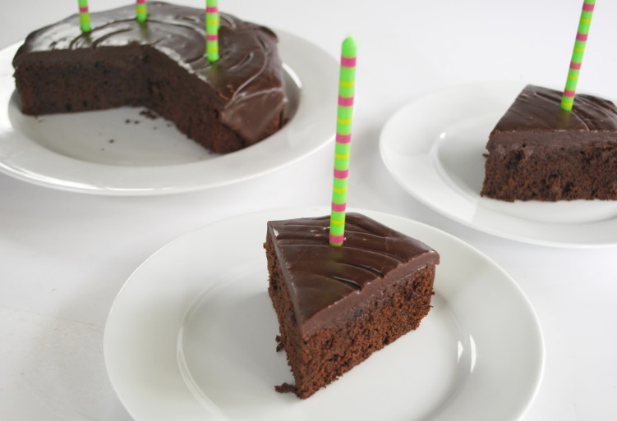

INGREDIENTS:

* 2 cups [Pamela's Chocolate Brownie Mix](http://www.pamelasproducts.com/products/baking-mixes/pamelas-chocolate-brownie-mix/) (we buy the 25# bags off Amazon without the chocolate chunks added. In a pinch you can use one 16 oz. bag from the store)
* 2 eggs, large
* ½ cup sunflower oil
* ½ tsp baking powder
* ½ tsp baking soda
* ¾ cup coconut milk

DIRECTIONS:

Preheat oven to 350°. Combine all ingredients and mix thoroughly. Pour into greased 8 or 9-inch pan. Bake for 30 to 35 minutes. It will also make 16 cupcakes, baked for 22 minutes. Cake should be firm to the touch. Do not over bake.